Instructions for downloading and logging into Microsoft Teams

You have two options to choose from:
Option 1. Download the program to any device.
Option 2. Log in to the program via the website.

Option 1
https://products.office.com/pl-pl/microsoft-teams/download-app
Microsoft offers two versions:
- Classic (pobierz wersję klasyczną aplikacji Teams),
- Mobile (pobierz aplikację mobilną Teams).
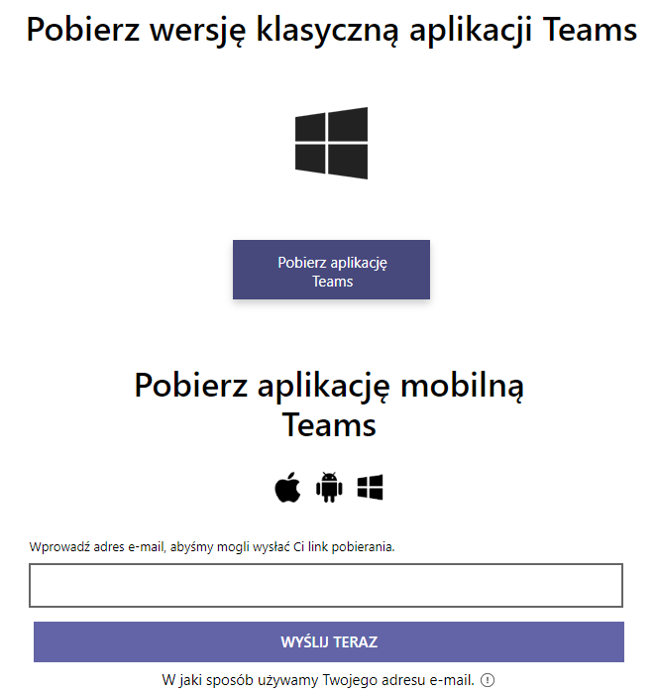

After installation log in using your e-mail:
[album number]@student.uwm.edu.pl
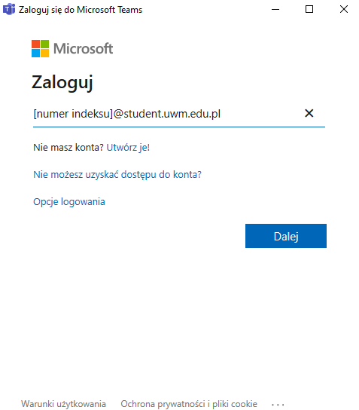
[album number]@student.uwm.edu.pl
Click „Dalej” and program will transfer you to the Centralny System Uwierzytelniania UWM –cas.uwm.edu.pl.
From the drop-down menu pick „Logowanie w domenie student.uwm.edu.pl”

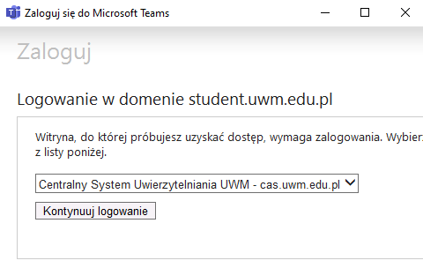
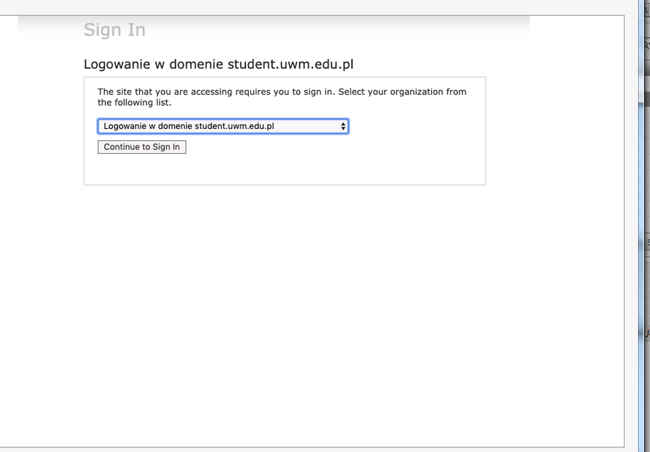
Log in using your e-mail (album number@student.uwm.edu.pl) and a password.

Program gives you an option to be permanently logged in (if you want it click “Tak”):
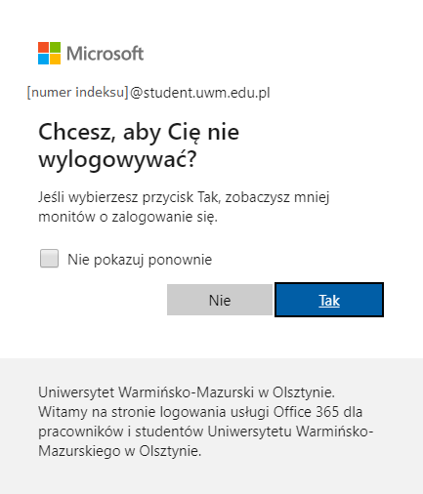
After choosing an appropriate option, you are logged into the system.

Option 2
Download program from:
https://products.office.com/pl-pl/microsoft-teams/group-chat-software
Click „Zaloguj się”.
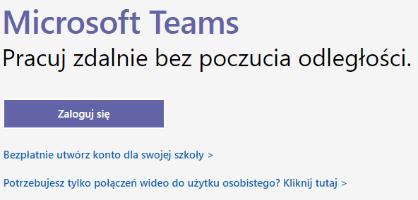

Log in using your e-mail:
[album number]@student.uwm.edu.pl.
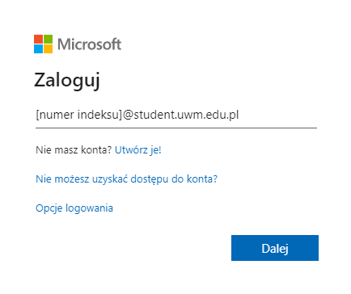
e-mail: [album number]@student.uwm.edu.pl
Click „Dalej” and program will transfer you to the Centralny System Uwierzytelniania UWM –cas.uwm.edu.pl.
From the drop-down menu pick „Logowanie w domenie student.uwm.edu.pl”
Log in using your e-mail (album number@student.uwm.edu.pl) and a password.

Program gives you an option to be permanently logged in (if you want it click “Tak”):
After choosing an appropriate option, you are logged into the system.

- How to use the program

To join the class (Zespoły) click „Dołącz do zespołu lub utwórz nowy”. Pick the appropriate class.
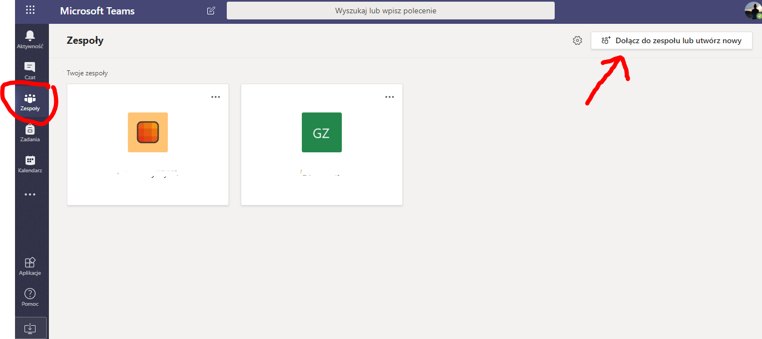
In an empty field „Dołącz do zespołu, wpisując kod” write a code sent you by a teacher.
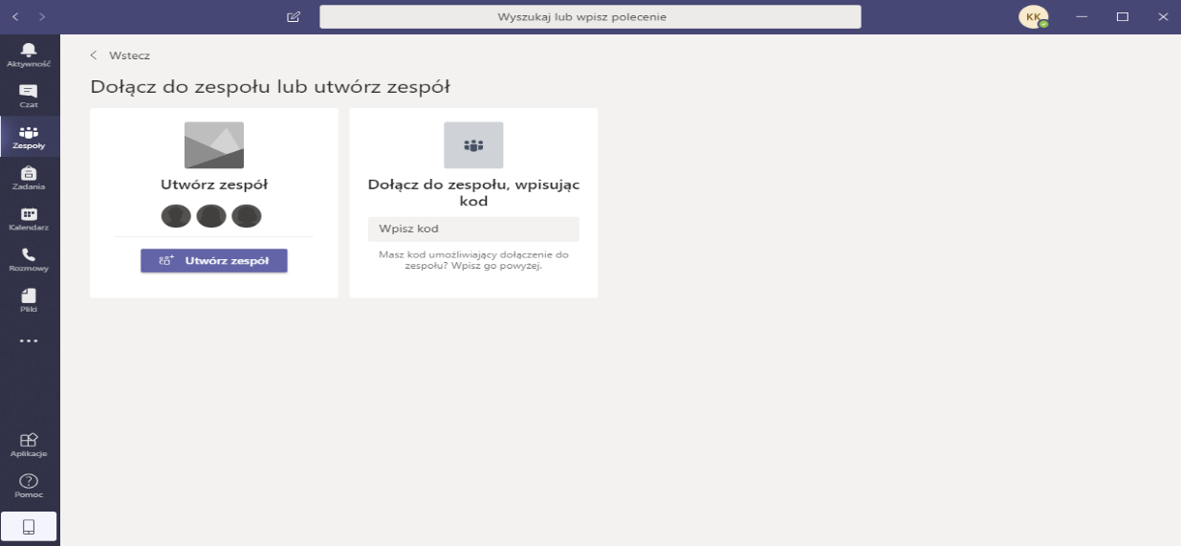
Write a code here

To change language:
Open an icon with your initials in the top right corner of the window

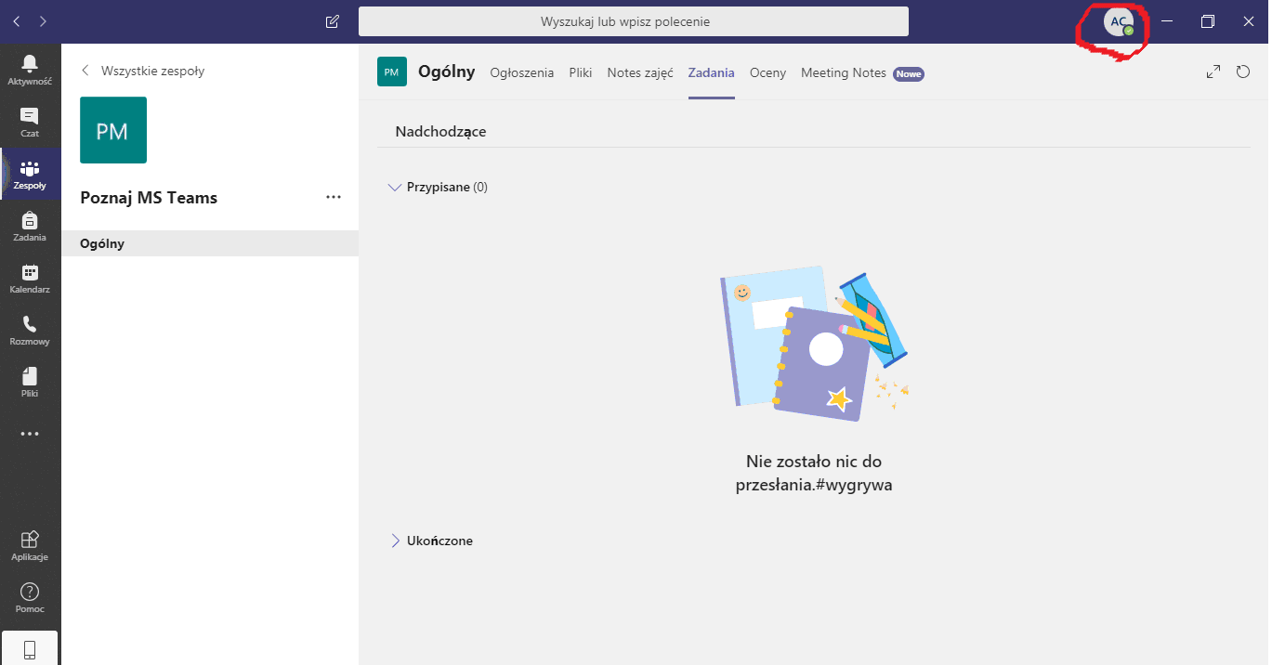
Open settings (Ustawienia)
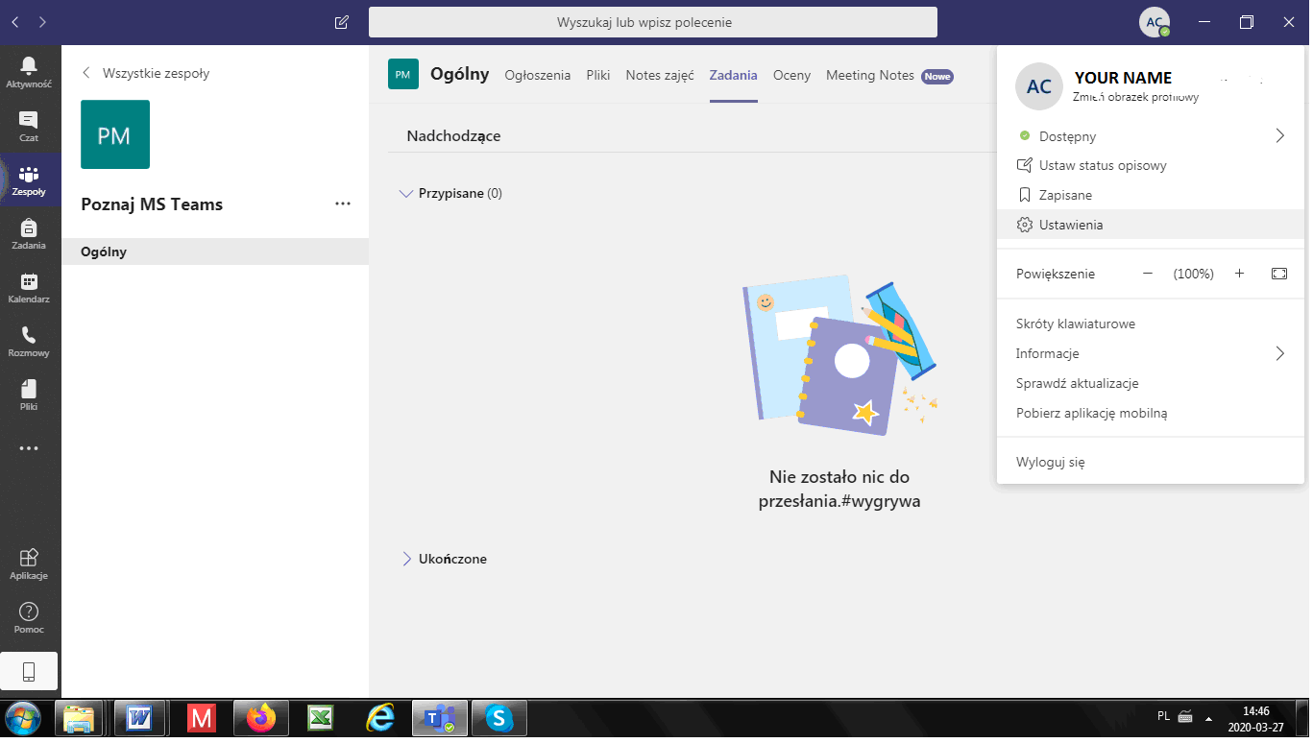
Change the language (Język)

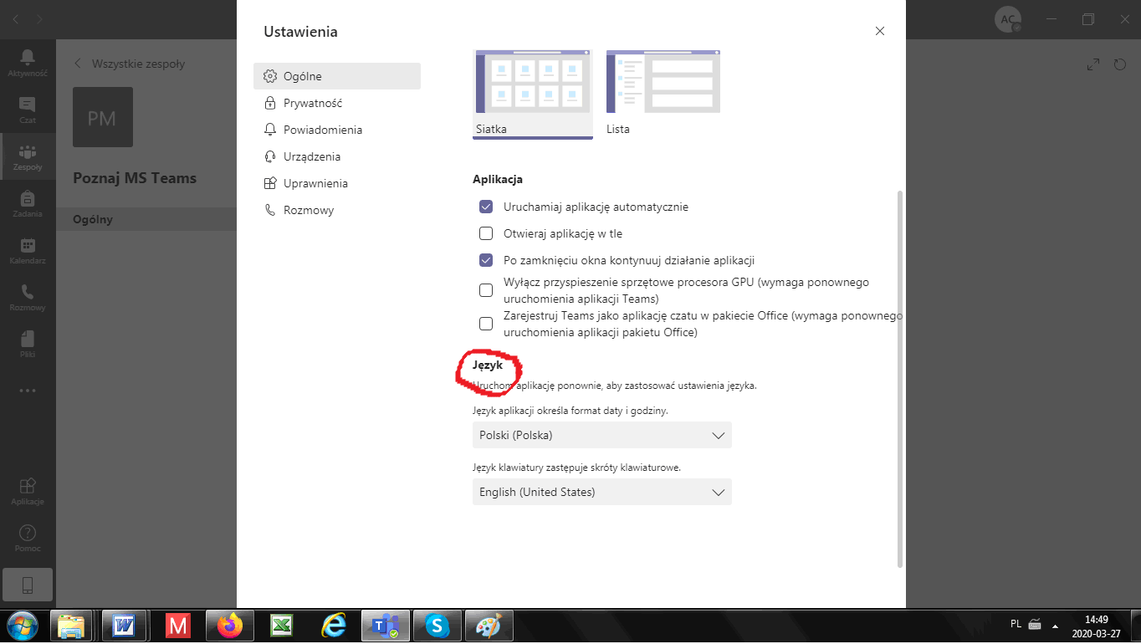

Good luck!

